To: Art Museum
From: Christos Giannopoulos
Date: subject
Subject: Art museum database environment

This Memo has been developed regarding an Art Museum that needs to keep track of its artist’s art work and locations in which Art work has been displayed in the museum. This Memo will act as a supplement for the original Memo and it will include database design and ERD.
Logical design
A logical design can be referred to as an abstract and conceptual framework. The main aspect of a logical design is that one is only required to the types of information required. It defines the relationship between attributes and entities. This discussion aims to show how attributes and entities are related. The logic design is explained in three tables.
Art table
The art table consists of 5 fields including:
Art ID (Primary Key), Date Created, Size, Genre and Value
Artists Table
The artist tables also contain 5 fields including:
Art_Id, Artist_ID, Name, Phone No, Art amount and Physical Address.
ARTIST_ID is the primary key, while ART_ID is the foreign key.
Art Location Table
The location table includes:
ID (Primary key), ART_ID (foreign key), Location, Section, Beginning Date and End Date
Entity Relationship Diagram (ERD)
Data Types
Data types selection should be taken seriously and done with a lot of concentration. Data types and keys are presented in the tables below.
Art table
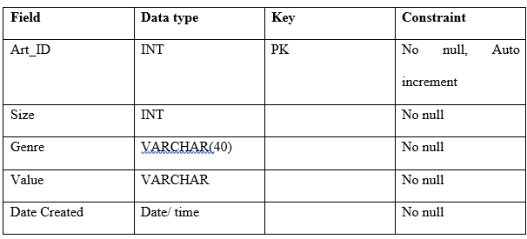
Artist table
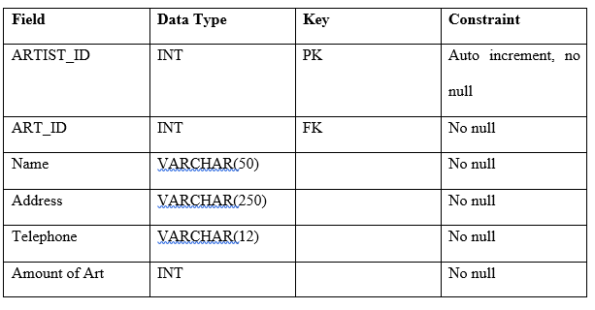
Art location table

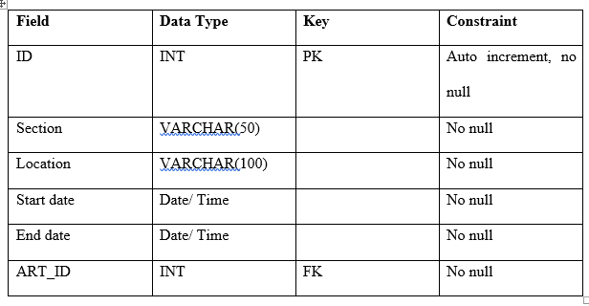
Figure 1 ERD DIAGRAM
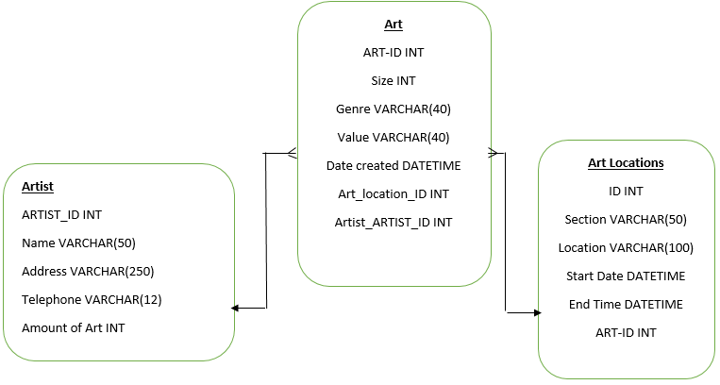

References
Lucid Software Inc. (2015). ER Diagram Symbols and Meaning. Retrieved from
(https://www.lucidchart.com/pages/ER-diagram-symbols-and-meaning)
Microsoft Corporation. (2015). Database basics. Retrieved from (https://support.office.com/en-us/article/Database-basics-a849ac16-07c7-4a31-9948-3c8c94a7c204?CorrelationId=719a00a5-8bfd-4e6f-aea8-d644785051a7&ui=en-US&rs=en-US&ad=US)
Oracle. (1996-2000). 2 Overview of Logical Design. Retrieved from (http://docs.oracle.com/cd/A87860_01/doc/server.817/a76994/logical.htm)

